**Objective question 10**

I the (c) and (e) answers. The block force in the spring is equivalent in size and identical to the spring force on the board.

(ii) the (c) or (e) answers. The spring stress exerting forces of the same size at both ends in the middle of the flow.

**Objective question 15**

I Response: a = b = c = d. In points even smaller than the planet's circumference, the gravitational force is accurate.

(ii) Reply: c = d > a = b. The density but not the height influences the force of gravity.

Response: C > b = d > a. Response: The objectEarth system's gravitational potential energy is proportionate to mass levels.

Problem 3

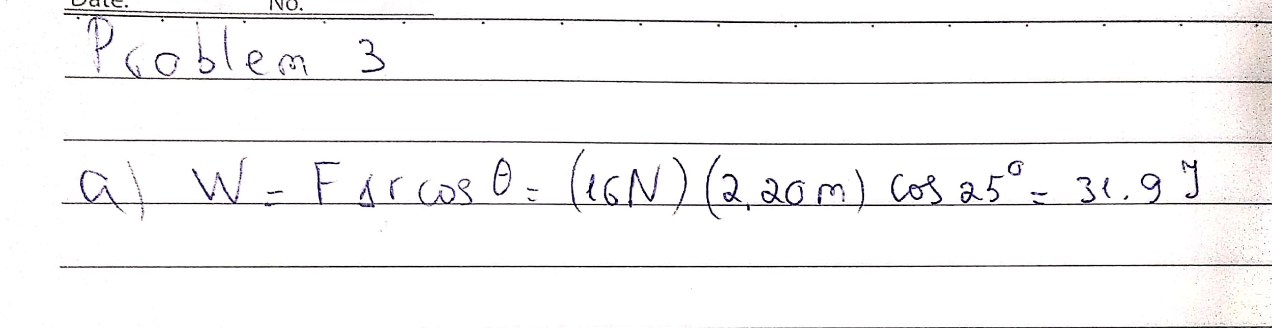

Problem 48

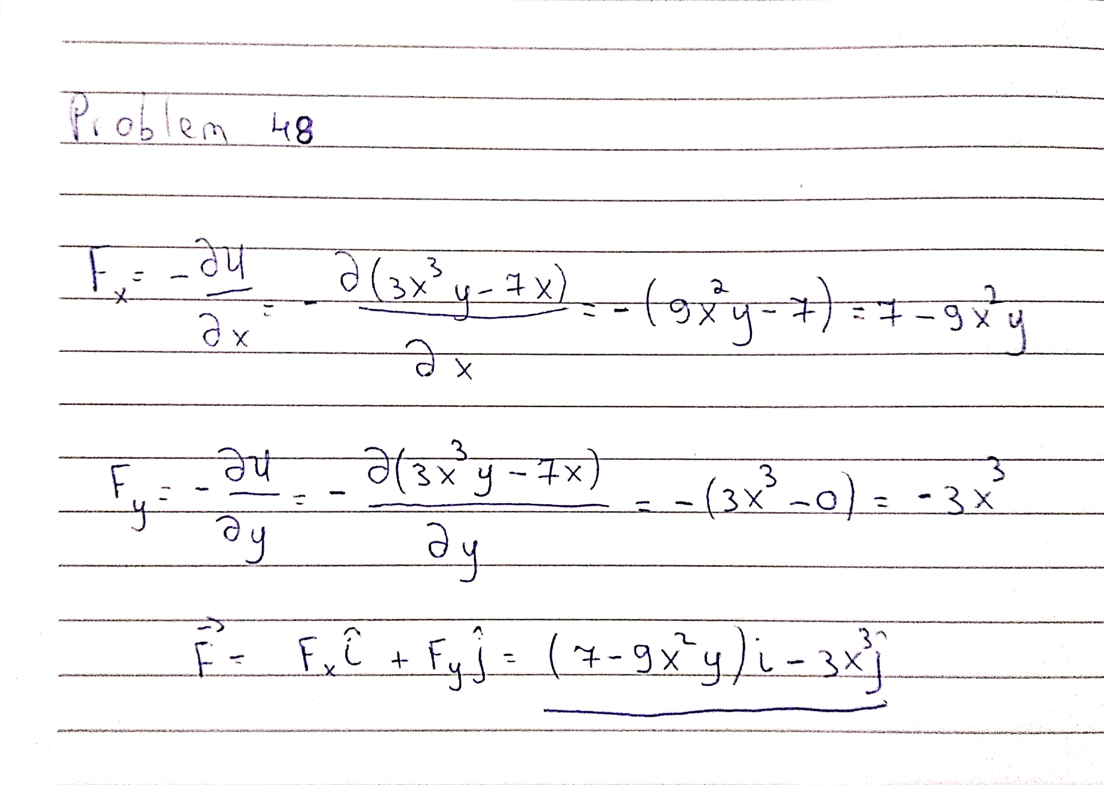

Thank you

Student ID : 201923250

Name : Kobilov Ilkhomjon